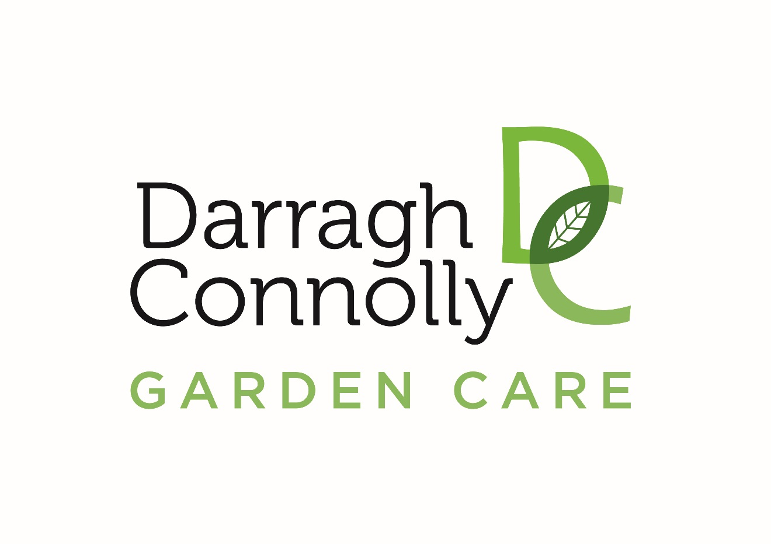

Mission Statement & Policies

Date:01.01.2018
Darragh Connolly Garden Care was founded by Darragh Connolly. Darragh started in the horticulture sector in 1997 & has had a few endeavours with the landscape industry but Garden care has always being the main integral part of the business. Our slogan is
“Building business through client referral & satisfaction”
We pride ourselves in carrying out the best work possible for a client using the best quality tools & the most efficient way. Darragh Connolly Garden Care is dedicated to meeting and exceeding our customer’s goals and expectations with the highest quality products and services, produced in the timeliest fashion, by the finest landscape professionals.

A Group of Gardeners-same standards
It is the mission within Darragh Connolly Garden care to achieve the same standard of work within each garden ie it doesn’t matter who is carrying out the work but the same standards are achieved. We all should work to the highest of standards. It is the aim that we are the best garden care company to hire.

Hotel Manager Eye
One of the key parts in our job in having what we are going to call ‘the hotel managers eye’. Our aim is to achieve the highest standard in every garden. The hotel manager’s eye though refers to what the clients sees first. Driving into their property & up their entrance into their house must be pristine at all times. Keeping areas weed free, blown & raked in of utmost importance

Equal Employment Opportunity
It is our policy and intent of our company to provide equal opportunity to all qualified persons. This policy prohibits discrimination. The company’s policy applies to all phases of the personnel process, including recruitment, hiring, placement, training, promotion, benefits, compensation, company sponsored social activity and all other terms and conditions of employment.

Classification of Employees Introductory:
An employee appointed to a regular position by the company shall be considered introductory for a period of three 6 months. During the introductory period, an employee may be terminated from employment at any time without the right of an appeal.
Regular Full-Time: An employee who has successfully completed the introductory period shall be considered regular. Regular employees are full-time if they are regularly scheduled to work at least 40 hours per week with the intent to work on a year round basis.
Regular Part-Time: After completing the introductory period, an employee will be described as part-time if employed to perform work which can be accomplished on less than a full-time weekly schedule.
Seasonal: An employee who works during peak periods only (i.e. summer season) will be considered seasonal. Although subject to the introductory period, once this is completed, the seasonal worker will not have to re-complete that period if they stop working and return later for another reason.

Basic Training
At Darragh Connolly Garden Care we believe it is to our mutual benefit to provide the very finest job preparation. The training will be on-the-job under the supervision of an experienced person. You will acquire the skills and knowledge to use tools and equipment that are essential to the position to which you were hired. The training process will be on going and will enable you to learn the operation of more advanced equipment and new techniques in the field. Advanced Training In some cases, additional outside workshops, seminars and clinics will be necessary to attend. These sessions will sharpen your skills, update your knowledge and provide a deeper understanding of your job and the landscaping industry in general.

Performance Review
The ability to do your job well is critical. Darragh Connolly Garden Care’s philosophy is one of continuous quality improvement in the work that we do, services we provide and professional working relationships that we maintain. Towards the end, you should continuously evaluate your performance as your manager will do the same. If you ever have questions about your performance or opportunities for improvement or professional growth, talk to your manager. We will also conduct formal performance reviews at least once a year. Generally these reviews will take place on or about the employee’s anniversary date. New employees will be given an oral evaluation at the end of the introductory period and then again at the employee’s anniversary date. A performance review may also be conducted in the event of a promotion or change in duties and responsibilities. Should any employee’s performance indicate a need for improvement, a follow-up review will occur after a period of time to allow for that improvement. When a written appraisal has been prepared, you will be allowed to review it and add any comments you wish. It is you’re responsibly to take advantage of this process and to develop the skills necessary to perform your job satisfactorily

Safety
Darragh Connolly Garden Care is dedicated to the safety of its workers. The utmost care must be taken at all times to ensure that safe work practices are utilised. This means using full PPE equipment including all guards on equipment, wearing head and eye protection and steel toe work boots, safe use of chemicals, no smoking near flammable materials and cautious and courteous driving. With assistance from the field, we can utilise our resources to identify and control work related hazards. All employees are encouraged to actively participate by notifying your supervisor of any needed safety improvements. If any injury or accident occurs, these procedures should be followed:
• Report all accidents to your supervisor immediately, regardless of the nature or severity; • Seek medical assistance if the situation warrants. Failure to receive treatment may result in serious complications
• An Employer’s Accident/Injury Report on all employee accidents must be completed within 24 hours of the accident/injury and turned into the Human Resource Department. Failure to report an injury or accident immediately is in direct violation of an important company procedure.

Attendance
In no area do we have more employees than our needs require. This means that when an employee is absent, it may cause a change in other employee’s work schedules or cause jobs to go undone. Therefore, a conscientious effort should be made by all employees to be prompt and on the job when they are scheduled to work. If you are going to be late or absent from work, notice of at least 1 ½ hrs is required or notice as soon as practical. Unreported absences or tardiness’ are considered unacceptable conduct on your part and will lead to disciplinary action. A reasonable absence or tardiness will be acceptable if prior notification is given and approval is given. For sick days, a doctors cert will be required to verify the illness. Any time missed due to illness, absence or tardiness will not be compensated for.

Care of Equipment and Company Property
It is the duty of all employees to take due care with regard to company equipment and property. Part of the pride you have in the company is shown in the manner you treat its property. Any breakage that occurs to any equipment should be reported to a supervisor immediately. This will eliminate unnecessary down time for that piece of equipment and allow for proper and timely completion of the job. It is understandable that equipment will break under normal operating conditions, but carelessness and abuse in using the equipment will make that user responsible for repair or replacement of that equipment or property. The repair cost or replacement cost will be shown to the employee and the cost may be deducted from their check, in accordance with federal and state wage and hour laws. Wilful or careless destruction and damage to company property will not be tolerated. Company vehicles can be used outside of work hours (to a point) but fuel should be supplied by the driver of the vehicle

Criticisms and Grievances
We welcome constructive criticism on the part of every member of our company. Airing a grievance with a fellow worker often enhances the problem, whereas a discussion of the same problem with your supervisor may bring about a speedy and satisfactory solution. We expect your cooperation in this matter. No employee may be subject to retaliation or reprisal for airing a criticism or grievance with his/her supervisor.

Holiday Policy
All regular full-time employees are entitled to 20 paid holidays. Holidays are based upon a calendar year. Unused vacation time cannot be carried over into the next calendar year. Darragh Connolly Garden Care has a “use it or lose it” holiday policy unless a specific exception has been approved by the manager. Holiday requests should be submitted to your supervisor at least thirty 30 days prior to dates of vacation approval. Part time employees and seasonal employees are not entitled to paid holidays.
Due to the seasonal nature of this business, holiday time between the months of March and June, September through mid-November cannot be guaranteed. Please try to schedule them at other times of the year. If work commitments are such that you are asked to postpone your vacation, please accept it gracefully. Any earned but unused vacation time will be paid out upon termination of employment. Any earned but unused vacation throughout the calendar year will be paid to the employee monetarily at the end of the year.

Lost & Found
If an employee has come across an object or equipment belonging to some other company and feels they are obliged to bring it back to the owners they must let the manager know of their actions immediately. Not knowing this information will be treated seriously.

Record Keeping
The driver/foreman of each vehicle is obliged to fill out the timesheets & report form on a daily basis

